Problem Statement 3:

Modify the previous program to take multiple HDFS paths (separated by space) and list all the files and sub-directories in those HDFS paths recursively.

Code: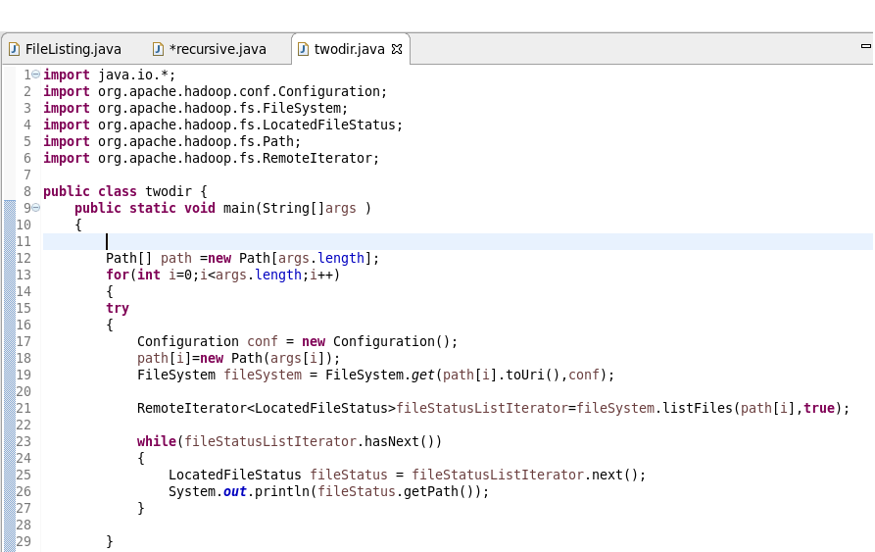

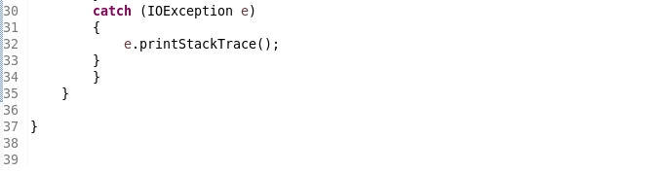

Output:

